PHYSIOTHERAPY SELF REFERRAL FORM
Please complete in Block Capitals
This form should only be used for patients wishing to have physiotherapy for musculoskeletal problems (back/neck pain, joint pain, soft tissue injuries). If you are under the age of 16, or wish to have treatment for a lung or respiratory conditions, a neurological problem such as Multiple sclerosis, Parkinsons, Stroke, or an obstetric/gynaecological problem, you would have to be referred by your GP in the normal way and to the appropriate Physiotherapy service.
Full name: |  |  |  | D.O.B:
Occupation:
Address: |  |  | Post code:
GP Name  Practice | Telephone Numbers. Can we leave a message (please circle)?  Home YES NO  Work YES NO  Mobile YES NO
Do you have any special requirements? (e.g. interpreter) YES NO
If yes, please supply further information:

Please complete for your main problem only  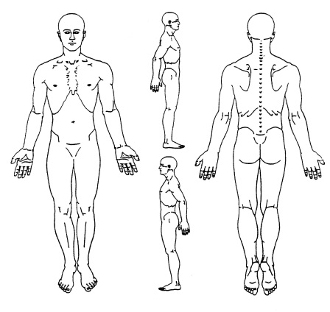 |  | Please mark on the diagram the location of your main problem.  Where is your pain?  Is your pain / problem due to a recent fall or injury? YES NO  Please describe your current problem and symptoms below:
How long have you had this problem? ………. Days ……….Weeks ……….Months ……….Years
How did it start? (Just came on, injury, fall, long term problem etc)

Is your pain: Mild Moderate Severe
Is your problem getting worse? Worse Better Same
Is there any previous history relating to the pain, or is it recurring? YES NO (if yes please give details)

If so, have you had any X-rays or other tests/treatment for this problem? YES NO (If yes please give details)

Is your pain causing you to be absent from work? YES NO
What are your expectations from Physiotherapy?

Signature

Date

Please call 02380 170 611 to arrange an appointment.
Please bring this referral form with you to your appointment.

